Python Assignment 04

248518 Gaurav B Raskar

Q.1.



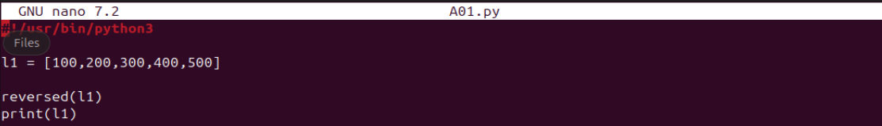

Q.2.

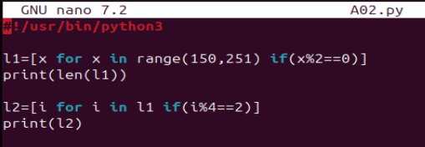

Q.3.

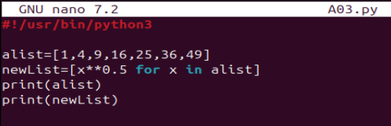

Q.4.

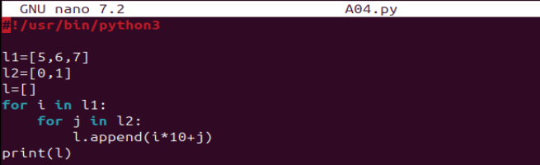

Q.5.

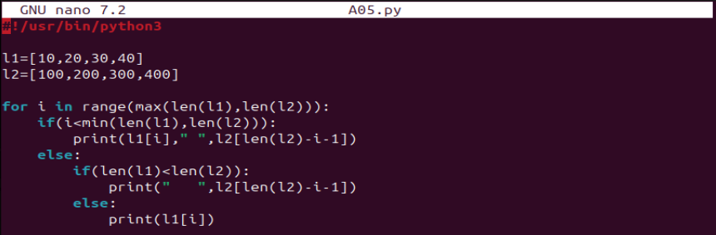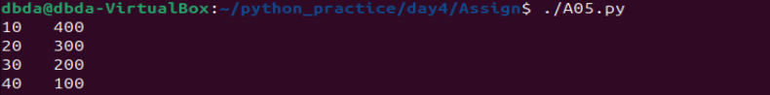

Q.6.

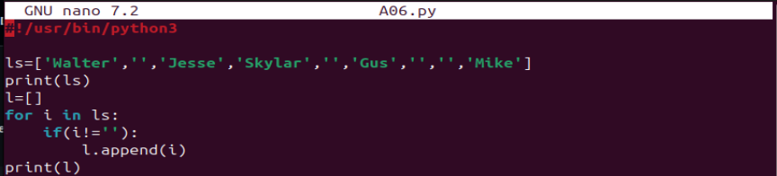

Q.7.

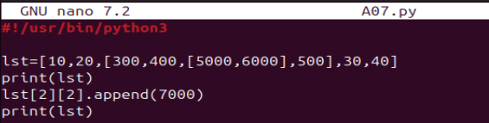

Q.8.